You will be creating a stylesheet for an already existing page. You can reach this page at <http://tophat.sunywcc.edu/~smiller/lab04.html>. Feel free to look at the source.

**Objectives:**

1. Collapsible menu in upper left
   1. with rounded corners
   2. box shadow
   3. Cursor should change when you hover on top of the Menu
2. Documents main text “Lorem ipsum”
   1. Text should be in a FONT that you find on the Internet and use “@import” to add it to your page.
   2. Text should also be arranged in 3, 2, or 1 column depending on the width of the browser window.
   3. The background should be a gradient, colors of your choosing, at least two different colors.
3. Animated soccer ball, this does not have to by anything as complicated as in the example, however, I want to see it move by using purely CSS (no JavaScript)
4. Text shadow in the main header, (ie Lab Three)
5. Top bar (header) and bottom bar (footer) should be a different color then the main document text area.

**Notes:**

A lot of the CSS3 items are not yet officially supported in browers. Therefore, pick a browner (recommend Chrome) and use the vender specific property values. Your page does not need to render correctly outside of your selected target browser.

**Images that are available to use in your CSS:**

ball.png (height 200px, width 200px)

**End result:**

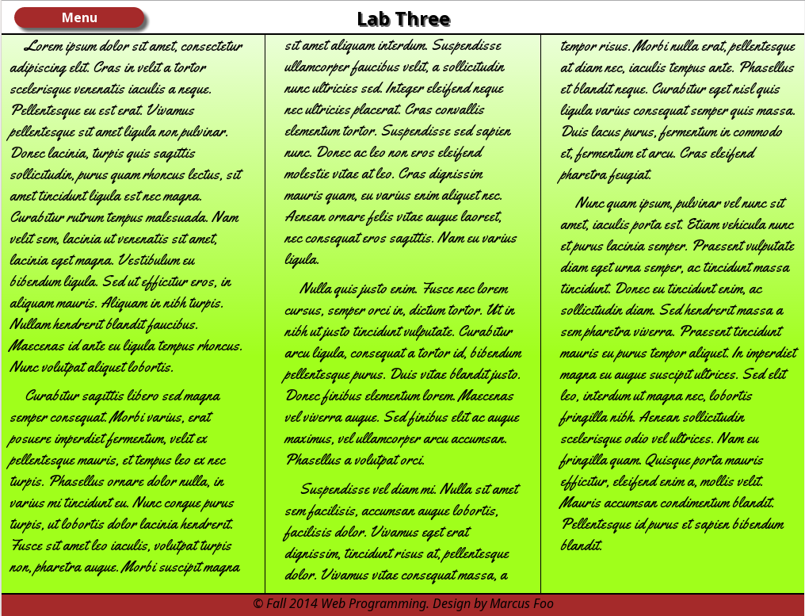

Example of rollover menu, when hovering over “Menu”

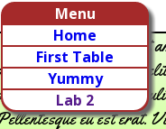

**Animation:**

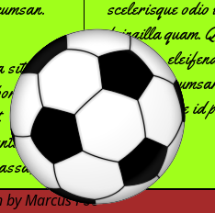

**Validation:**

HTML5 = <http://validator.w3.org/check>  
CSS3 = <http://jigsaw.w3.org/css-validator>